Fish Identification and Calculation System Using Artificial Intelligence of Things and Image Processing Technology

student：Wilson Wu, Pu Wang

professor：Cheng-Hung Lin

*Abstract—*Artificial Intelligence (AI) and Internet of Things(IOT) are booming in recent years. Thus, there are more and more application of Artificial Intelligence of Things (AIOT) to make our life more convenient. Our project is the application of both of above with the image processing technology to identify fish species and determine the fish size by calculating the fish length

*Keywords—* Fish Classification, Deep learning, Convolutional Neural Network, Canny, Edge Detection, Minimum Area Rectangle, Computer vision, Graphic User Interphase, Webpage.

# INTRODUCTION

Fishery has always been an important industry in Taiwan. However, it takes a lot of time to identify the fish species, calculate fish length and record it when fish is caught. Furthermore, the problem of fish stealing and selling often occurs.Therefore, we designed a device to solve the problem. We run Convolutional Neural Network on the Raspberry Pi 4b to identify fish species, and use python Open CV to capture the frame so that we can calculate the fish length in time and record it.Then we design a Graphic User Interface (GUI) to upload the fish photos and display the results on a web page.

The closest approach to this solution, is the fish classification paper [3] which uses a neural network for classification.This has a 96.29% of accuracy. Also, we use an image processing technology,called canny edge detection, to calculate the length of objects [4].

# SYSTEM ARCHITECTURE

## Structure and Device

The device is a Raspberry Pi 4b attached with a camera, a display screen, a board and a monopod.

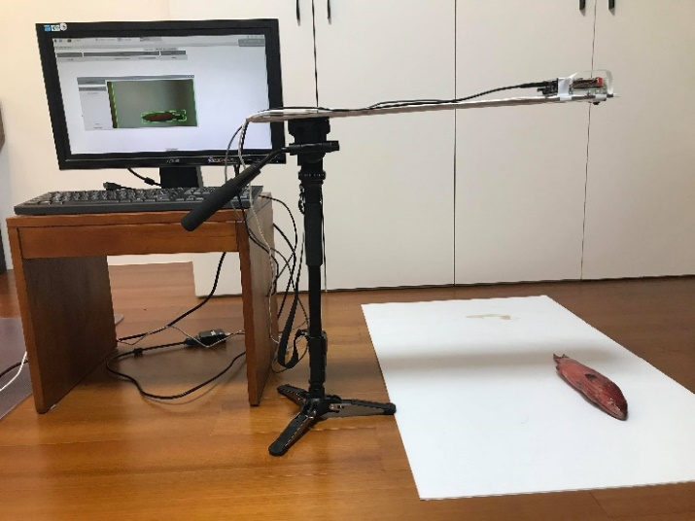

Figure 1: device.

Through the GUI, the photos taken on site or other existing images can be fed to the device for further analysis. Subsequently, we can identify the fish species and calculate the fish length. Finally, we can send data to the webserver to display it.

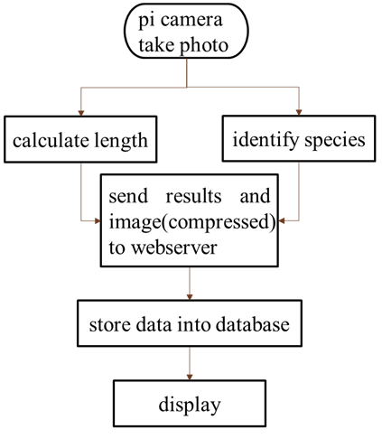

Figure 2: experimental procedure

## Model architecture

For the classification part of the program, a neural network was selected for this job. Originally it was decided to use the model YOLOv3-tiny [1] and YOLO v4 [2] for this purpose, but because the model was too big for a raspberry pi 4 to run properly and with high accuracy, we decided to discard the model.

Thus, the model we decided to use is inspired by the model that appears on the paper made by Rathi, D. [3], which better suits our requirement of lightness and accuracy. The difference is that our model has an extra fully connected hidden layer. The reason of this, is to give the network an extra layer of freedom. Also, in the third layer, the number of filter was changed, so the network can get has features map to work.

Table 1: architecture of the neural network.

|  |  |  |  |  |  |  |  |
| --- | --- | --- | --- | --- | --- | --- | --- |
| layer | number of kernels |  | size | stride | padding | activation | dropout |
| Inputs |  | 400x400x3 | | | | | |
| conv1 | 32 |  | 5x5 | 1x1 | 2x2 | ReLU |  |
| maxpool1 |  |  | 5x5 | 5x5 | 1x1 |  |  |
| conv2 | 64 |  | 5x5 | 1x1 | 2x2 | ReLU |  |
| maxpool2 |  |  | 5x5 | 5x5 | 1x1 |  |  |
| conv3 | 128 |  | 5x5 | 1x1 | 2x2 | ReLU |  |
| maxpool3 |  |  | 5x5 | 5x5 | 1x1 |  |  |
| Flatten |  | 1152 | | | | | |
| Dense1 |  |  | 2048 |  |  | ReLU | 0.2% |
| Dense2 |  |  | 2048 |  |  | ReLU | 0.2% |
| Dense3 |  |  | 5 |  |  | softmax |  |

## 

Figure 3: image of neural network architecture

## GUI and Webpage

### GUI

The device allows the users to take photos on site then upload them by clicking a button as shown below. Users can also directly feed other existing images to the device via the ‘file’ function. By clicking another button ‘calculate’, we can identify the species and calculate the fish length. With that, we send the results to a web server database to display it.

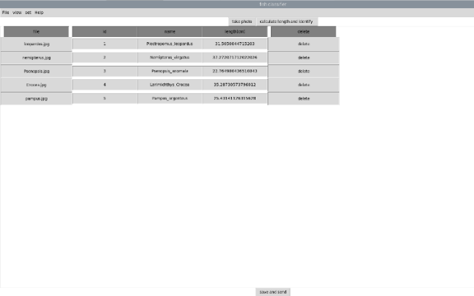

Figure 4: GUI

### Webpage

A webpage is made, ready with a search function, either by name or length, to display the results from the database.

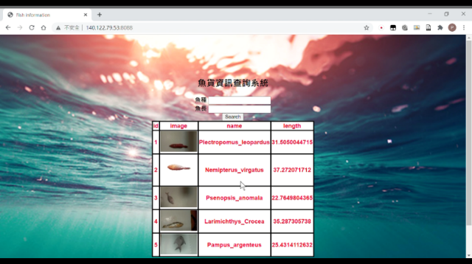

Figure 5: webpage

# Experimental Results

## Calculating the length

For this, methods of image processing and math were used to calculate the length of the fish. It consists of passing the input image through an image transformation to get the contour of the object and then with this

### Getting the contour

For this we test 2 types of transformations to get the contour, by Otsu’s threshold, and Canny transformation.

From the testing, we conclude that the transformation that better suit our necessity is the Canny transformation. The Otsu’s threshold is very sensitive to shadows, which might alter the returned image. In contras the Canny transformation return the contour of object that have very sharp edges.

Once having the counter, by using the method from Open CV called “minarearect” we obtain the number of pixels of the object.

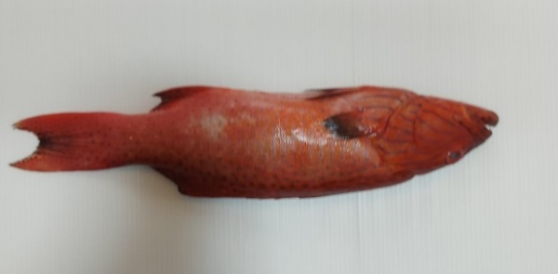(a)

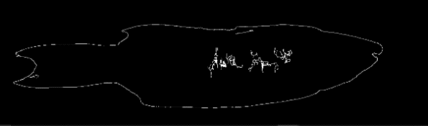(b)

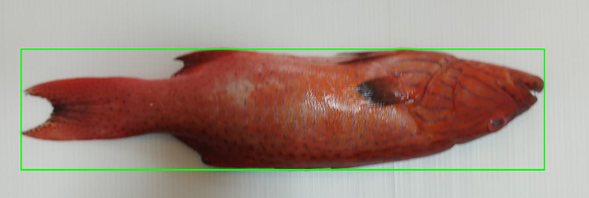(c)

Figure 6: image before (a) and after canny transformation (b) and after using the “minarearect” function (c).

### Calculating the length

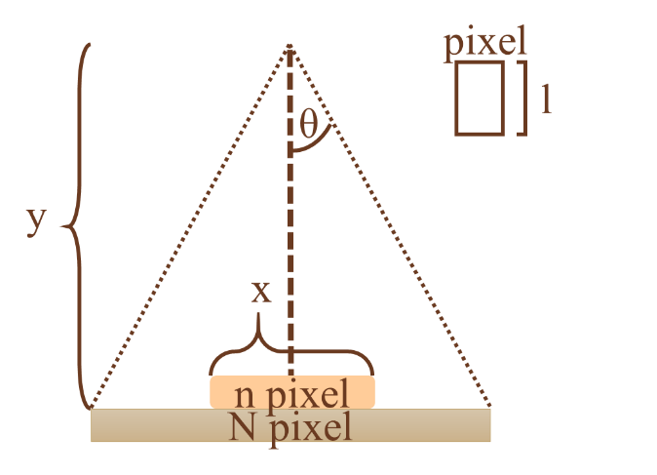

Figure 7: calculation graph.

To calculate the real length of the object first we need to know first the centimeter length per pixel, and for this we need $θ$ which is half the angle of vision in the x axis, the number of pixels in the same axis N and y, the distance between the camera and the object.

$l=$ (2 $×y×\tan{θ}$)/N

Once having the length per pixel, the real length in centimeter can be calculate by multiplying the length per pixel it was calculated before, by the number pixels of the object obtained with the “minarearect” function.

$$x= l × n$$

### Results

Due to the nature this method of being just image processing, this will not differentiate between objects. So, to get the best result, object must be on a single color background.

Assuming that this conditions are met, the results that the method gives has an average error of around 3%.

Table 2: error rate of each class.

|  |  |
| --- | --- |
| **Species** | **error rate of calculation** |
| Larimichthys Crocea | -0.87% |
| Nemipterus virgatus | 0.29% |
| Pampus argenteus | -10.60% |
| Plectropomus leopardus | -2.08% |
| Psenopsis anomala | -4.15% |

## Classification

### Testing the model

A dataset provided from the website [5] was selected for this purpose. In it, 10 classes with highest number of data was selected classes which have more data to train the neural network to see if it is worth using or not.

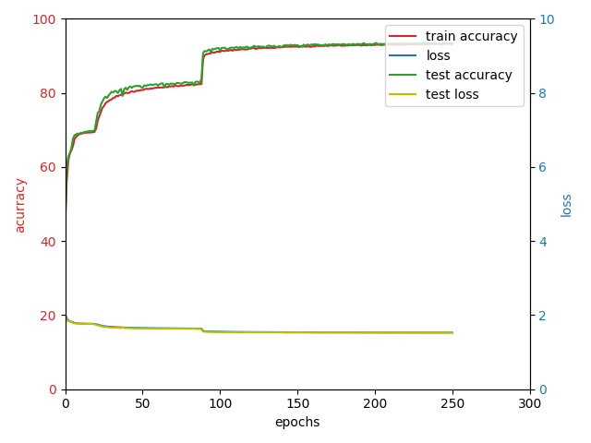 (a)

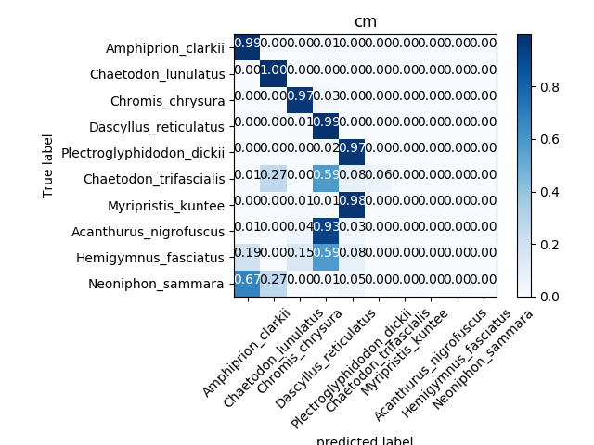 (b)

Figure 8: results using the test data set.

From the confusion matrix in figure 8b it can be seen a clear difference in the results between the classes. The upper 5 classes have been identified correctly with accuracy more than 97%. However, the lower 5 classes either have been misidentified or have low accuracy. The reason of this is that the distribution of the data is not evenly distributed. In this case the upper classes have much more data that the lower ones.

Despite this, it was concluded that, if the data evenly distributed between the classes and in a large amount, the neural network can be useful for our purpose.

### Our dataset

Since we couldn't find a proper dataset to meet your project’s needs, and it is difficult to collect data in fishing harbor, we decided to collect data in Taiwanese markets.

The dataset collected in Dongmen Market and Binjiang market consists of 5 classes of fishes that are common in Taiwanese fish markets, which are selected based on the amount of images we collected.are: Larimichthys Crocea (Fig. 9a), Nemipterus virgatus (Fig. 9b), Pampus argenteus (Fig. 9c), Plectropomus leopardus (Fig. 9d), Psenopsis anomala (Fig. 9e).

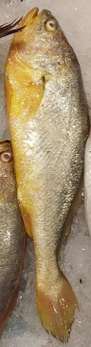 (a) 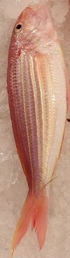 (b) 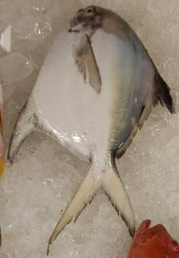 (c) 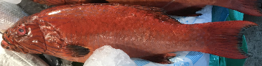 (d) 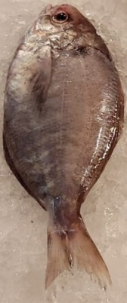(e)

Figure 9: Types of fishes.

Originally, the data set consist of photos that we took directly from the markets, plus some other images downloaded from the internet. Due to lack of images, which does not exceed 30 photos per class, the best accuracy that it was able to achieve does not pass over 80%.

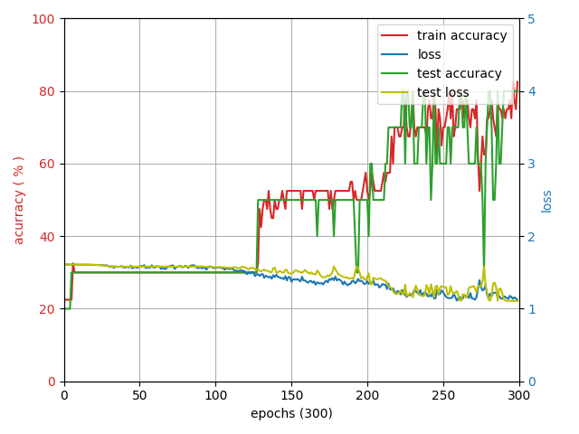(a)

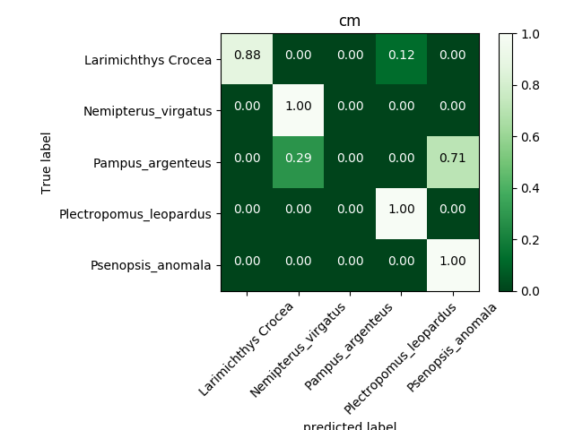(b)

Figure 10: results using the new data set.

From the confusion matrix of the model, it can be seen that the classes that has more trouble classifying are Pampus argenteus (Fig. 9c) and Psenopsis anomala (Fig. 9e). the reason of this is that, both fishes have a very similar shape, color and background, and because of this the nueral network cannot differentiate between this two, which indicates that the number of data we have is not enough. So we decided that we have to modify the dataset.

#### Preprocessing

Before feeding the dataset to the neural network, some extra preprocessing was made to artificially increase the dataset, to make sure that the model doesn’t over feat. These are: image random rotation, random horizontal or vertical flip, add random perspective, random image crop, add Gaussian noise and color shifting.



Figure 11: automatic data augmentation.

Also, because the model used needs a specific image size (400x400x3), we need to resize the image to meet this condition, but we don’t want the image of the fishes gets distorted, so if the image does not have the same image ratio we add black spaces, to match the aspect ratio and then resize.



Figure 12: image before (left) and after (right) the preprocess.

#### Manual data augmentation

To simulate real life conditions, we add methods that change the image for this goal. The methods we use to add extra data consist, using a photo editor and change the background of some of the fishes, the rotation with respect of the original photo, and changing the position of it.

The goal of this method is to make sure that the network can differentiate the fish from the background, and the fact that not all the fishes of the same class has the same shape, position, rotation and other small details.



Figure 13: output of the manual data augmentation.

This was applied on some of the fishes of every class. And with different backgrounds increasing from less than 30 photos per class, to more than 100 photos per class.

Table 3: number of training and testing data of each class.

|  |  |  |
| --- | --- | --- |
| species | number of training data | number of testing data |
| Larimichthys Crocea | 104 | 26 |
| Nemipterus virgatus | 118 | 30 |
| Pampus argenteus | 91 | 23 |
| Plectropomus leopardus | 75 | 19 |
| Psenopsis anomala | 104 | 27 |

By doing this we manage to increase from the original 80 % of accuracy to 96 % of accuracy.

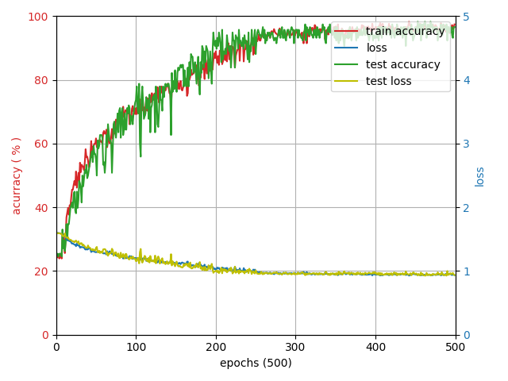 (a)

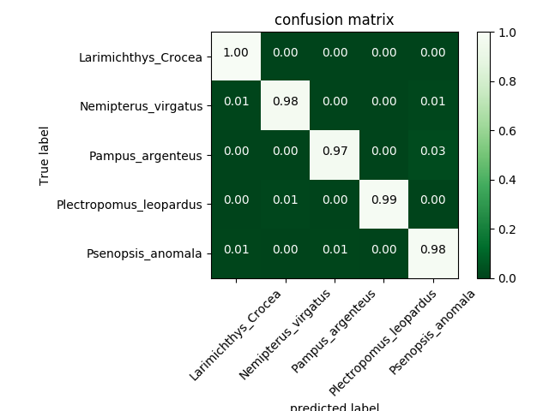(b)

Figure 14: results using the new dataset after the manual data augmentation.

Table 4: accuracy of each class.

|  |  |
| --- | --- |
| Species | precision of identification |
| Larimichthys Crocea | 100% |
| Nemipterus virgatus | 98% |
| Pampus argenteus | 97% |
| Plectropomus leopardus | 99% |
| Psenopsis anomala | 98% |

# Conclusion

Although our identification accuracy is more than 90% in all five species, the dataset is still too small that our results sometimes go wrong. On the other hand, data augmentation for training neural network in absence of sufficient data was very useful. We will continue to make the network more robust by adding new data.In addition, we will use some deep learning method to identify out-of-distribution data in future work.By doing so, we can decrease the error rate of identification and make our system more applicable.

# thank

Special thanks to the lab seniors and our professors for the help

# references

[1] Joseph Redmon and Ali Farhadi. Yolov3: An incremental improvement. CoRR, abs/1804.02767, 2018.

[2] A. Bochkovskiy, C.-Y. Wang, and H.-Y. M. Liao, “Yolov4: Optimal speed and accuracy of object detection,” arXiv preprint arXiv:2004.10934, 2020.

[3] Rathi, D., Jain, S., and Indu, S., “Underwater Fish Species Classification using Convolutional Neural Network and Deep Learning”, arXiv preprint arXiv: 1805.10106,2018.

[4] A. Rosebrock, “Measuring distance between objects in an image with OpenCV,” *PyImageSearch*, Apr. 18 2020. [Online]. Available: https://www.pyimagesearch.com/2016/04/04/measuring-distance-between-objects-in-an-image-with-opencv/. [Accessed: 14-Dec-2020].

[5] P. X. Huang, B. B. Boom, and Robert B., “Fish Recognition Ground-Truth data,” *Fish4Knowledge*, Oct-2013. [Online]. Available: http://groups.inf.ed.ac.uk/f4k/GROUNDTRUTH/RECOG/. [Accessed: 14-Dec-2020].

# 競賽心得

王樸:

經過這一次專題競賽真的是學到了非常多的東西，一開始的時候，題目是手語辨識，於是就開始接觸深度學習的知識，剛開始的時候什麼都不會，於是透過上網找教學影片、自己借書來看、請教學長等方式，對解深度學習的運作原理、計算、架構的使用方式有了基本的了解，此外也閱讀了許多篇論文，熟悉了幾種不同基本的深度學習架構。由於手語辨識在連續動作的資料採集上要達到足夠的訓練量有些困難，因此與教授討論之下後來題目改成魚類辨識。剛拿到這個題目時，以為應該不算太過複雜，應該不需要花太多的時間便可以完成，且原本以為有廠商能提供魚類資料，不需要自己去蒐集。最一開始的時候，我們對於裝置的樣子、結果該怎麼呈現等等完全什麼想法都沒有，經由討論、製作過程中才慢慢決定的。總共要完成的事情包括裝置設計、圖形使用者介面製作、資料傳輸、資料庫溝通、網頁架設，以上是額外得完成的周邊事項，最重要的部分是神經網路的架構設計、魚長計算方法、資料收集，此三者為最花時間的事情，由於我們兩個人都沒太多類似的經驗，所有事情都是從頭學起，格外辛苦，花了非常多的時間，每件事情都不是能夠短時間就順利的完成的。由於網路上的資料並不太符合我們現在專題所需之資料，我們實際走訪了三家市場超過十次，拍了幾百張照片，之後再將照片分別以影像處理的方式及手動的方式作資料擴增，增加資料的多樣性以防止過擬合，增加辨識率，此外我們買了兩隻魚回家測試。由於魚腥味非常重，在用來測試之前還要先做處理，以免汙染環境，此一過程非常的費工。在分工方面，我主要負責網頁、材料採買、資料傳輸等部分，而他主要負責神經網路架構設計、圖形使用者介面設計等部分，分工還算明確，各司其職。所幸在實驗室學長的大力幫忙以及教授的指點之下，能順利完成專題並展出，得到佳作，實在是非常的感謝。專題展的當天，看見了許多同學非常優秀的報告，覺得自己尚有許多不足之處須多加學習。期許希望未來升上碩士後，能夠藉著此專題經驗，來完成更複雜、更厲害的研究。

吳承威:

This experience was very enriching. In it, I learned how to work in a team. I also understood the method in which one works in an investigation. Like, for example, how to select an article on which to base my work and how to experiment. Also, I learned how to write a scientific article. I understood how this is structured, how to select what is imported to communicate well the work, the conventions and to cite.

However, the journey to our goal was filled with problem. At the beginning the selection of the topic was not easy, due to the inexperience in the field, so we appeal to the head teacher for ideas.

We spend an entire semester in our first project idea, but with little to no progress. This first idea consists on a sign language decoder based on a neural network, it was too difficult to archive for a lot of reasons, mainly caused by the lack of data needed to train the neural network and how difficult it was to collect new data. Plus, the fact that there are a lot of different sigh languages depending on the country which made thing more difficult. However, it helped us to learn how to use and write a neural network on PyTorch, also to learn how to use yolov3.

Then after we moved to the next and final idea, the fish classification and length calculation based on computer vision and artificial intelligence, we met with the same problem as the previous idea, the lack of data. Originally when we spoke to the teacher, we though that a data set will be provided, but in the end what we though did not happen, so we decided to get the data. However, this time the data can be obtained with more ease, but for it we must spend a lot of time to get them. Also we spend a lot time on a neural network, yolov3, that won’t be used because the machine that will be used cannot run the program at a reasonable speed.

Others problem that happened during the project regarding to the raspberry pi is that we don’t know how to use it and the fact that lot of the python libraries must be installed manually didn’t help us. For example, we spend two to three weeks trying to install opencv2 in the raspberry and other two weeks installing PyTorch, and in the process the raspberry pi memory got corrupted, delaying our plans. Plus, the camera that is attached to the raspberry broke, so we had to wait a week until we could buy a new one. And last but not least important, the fact that the raspberry pi process capability is not very high, make us spend more time try to make image that is shown in the GUI at a decent frame per second so the user can see what the camera is capturing with ease.

Also, while testing the prototype near the deadline, we find out that the original method that we use to get the contour of the fish, what heavily influenced by the ambient lightning, so we had to spend more time to find a better solution to this problem. other problem we encounter in the test, is that the network was over fitted and to prevent it we had to re train the network so the test had to be postpone week.

All in all, we managed to resolve all of them, and in the end the project was done successfully before the deadline.

Regarding the competition, it was very helpful. we learned how to communicate our work quickly and concisely, at the same time, it helped me to realize the mistakes we make in the presentations, so we don’t repeat them in the future. we also got to see projects from other students, which were interesting.

But this process was not done without, inconvenience, especially for me, I have a language problem, and doing a presentation in the other language is very difficult even if I have a deep understanding in what I am talking.

Also, something that make me confuse, is that, during the presentation the presentation one of the judge teachers ask us about mobilenet and said that it is not an architecture but a method, but when I read the paper about it, it clearly is a neural network architecture and not a method. So I’m not if the paper that I read is wrong or the teacher.

In the end, I’m satisfied with the result of the project however, I know that there is plenty of room for improvement that due to the time limitation we couldn’t do. For example, have more classes to classify which can be solved with a better dataset made by people that are more related with the topic, which could prevent a lot of the over fit problem that we have. Plus, to consider the questions made by the teachers during the competition, that we didn’t thought about during the process.

# 競賽回覆事項

問題1:MobileNet是不是一個神經網路?

回答:是。它是由多層卷積層所組成的神經網路。

問題2:為什麼要用canny進行邊緣偵測而不直接送進cnn?

回答:因為cnn雖然可以找到輪廓，也可以框出物體，但是會造成神經網路過大，執行速度緩慢，故用opencv 之canny函數進行邊緣偵測以及minarearect函數框出物體，得以快速地計算出魚之長度。